# Empirical Bayes

## Introduction

*Its approximations become inaccurate when you have only a few observations.*

Full Bayesian methods that use **Markov Chain Monte Carlo** (MCMC) are useful when *performance is less important than accuracy*, such as analyzing a scientific study. However, production systems often need to perform estimation in a fraction of a second, and run them thousands or millions of times each day.

**Bayesian statistics** is a way of modeling our prior expectations against the current data observed.

**Empirical Bayes estimation**, where a beta distribution fiton all observations is then used to improve each individually. As long as you have a lot of examples, you don’t need to bring in prior expectations.

## Batting average rate

**Batting average** is the number of hits (H) divided by the number of at-bats (AB):

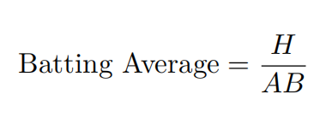

.270 (27%) is considered a typical batting average, while .300 (30%) is considered an excellent one.

The number of hits a player gets out of his at-bats is an example of a **binomial distribution**, which models a count of successes out of a total and the best way to represent the prior expectations is with the beta distribution.

## Beta distribution

This is the Bayesian philosophy in a nutshell: we start with a prior distribution, see some evidence, then update to a posterior distribution.

The following distribution represents the historical batting average of players.

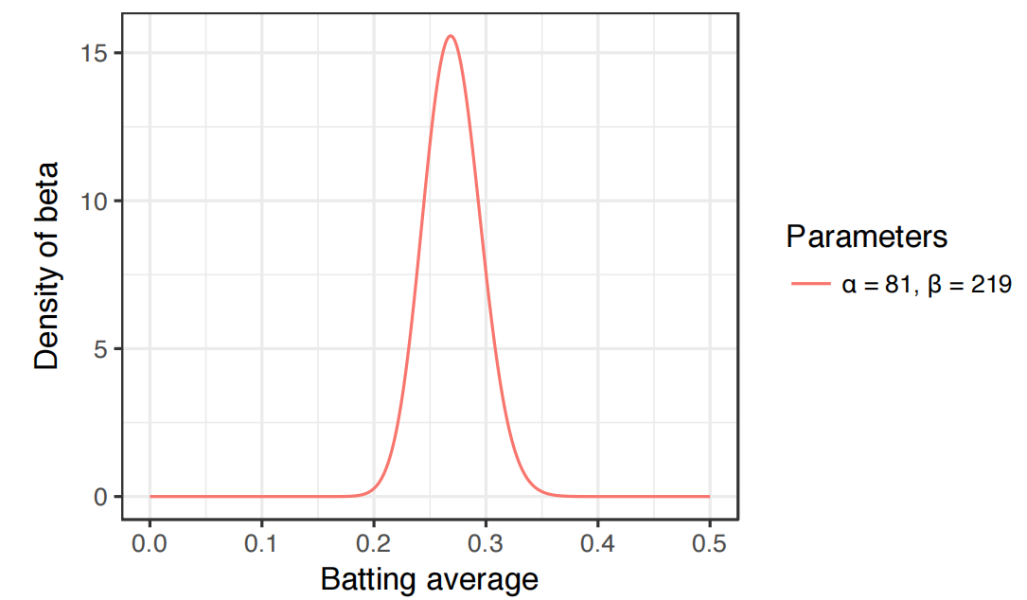

Imagine the player gets a single hit. His record for the season is now “1 hit; 1 at bat.” We have to then update our probabilities- we want to shift this entire curve over just a bit to reflect our new information. According to that our new parameters will be:

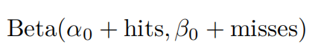

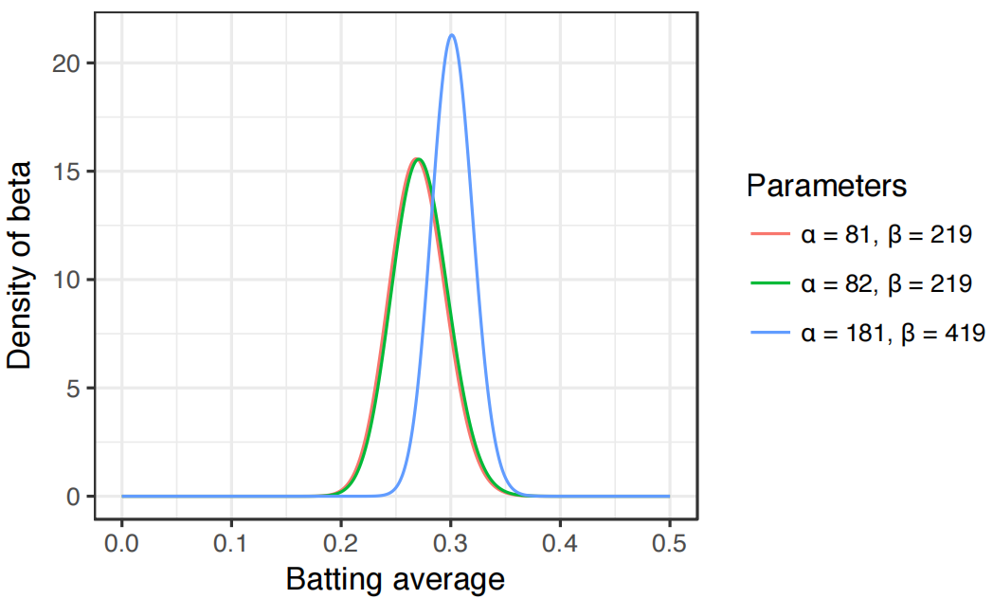

The Expected value of the blue curve can be calculated using the next formula:

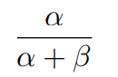

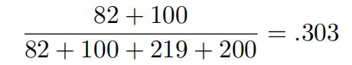

Let’s the this with a simulation.

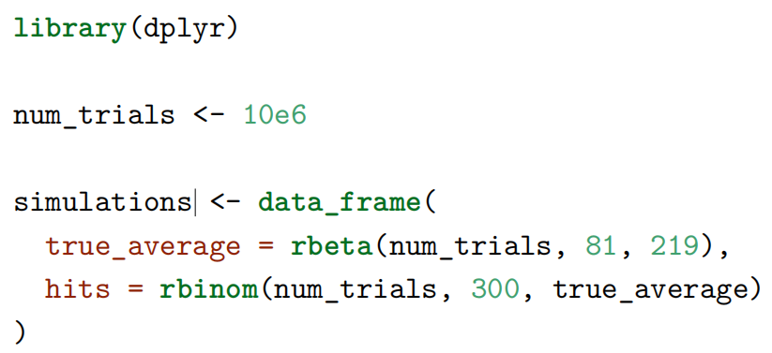

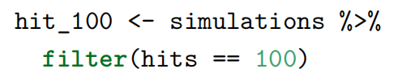

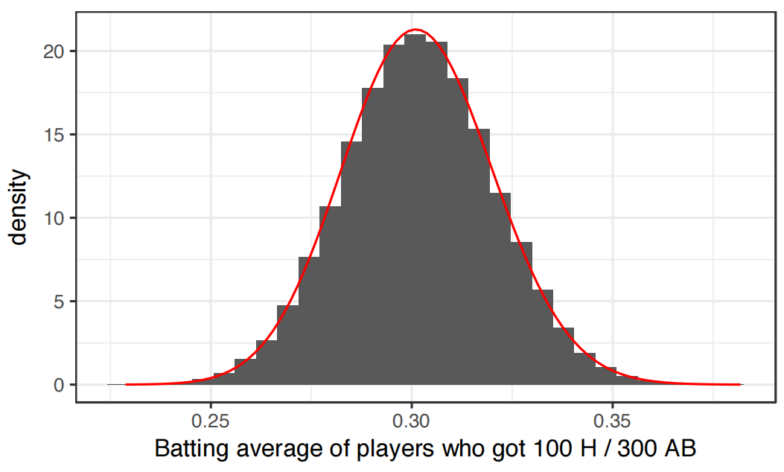

## Empirical Bayesian shrinkage towards a Beta prior

1. Estimate the beta distribution using prior data

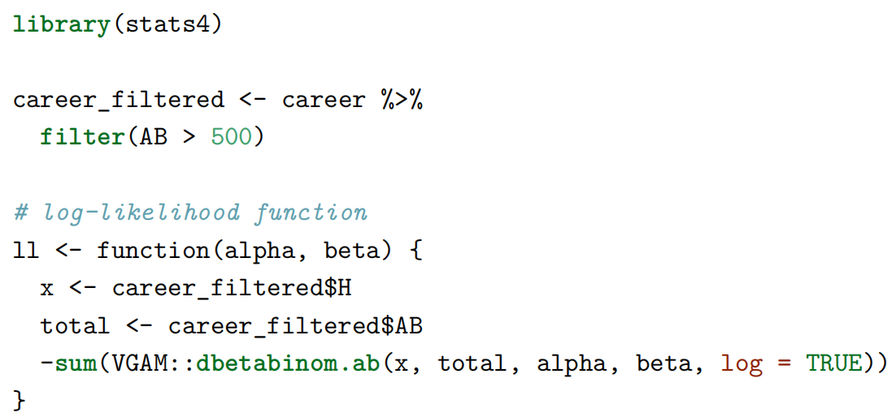

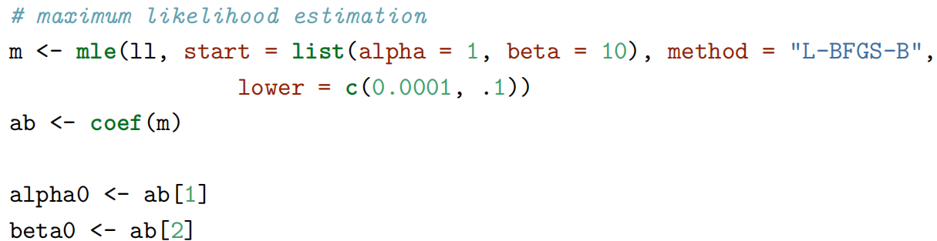

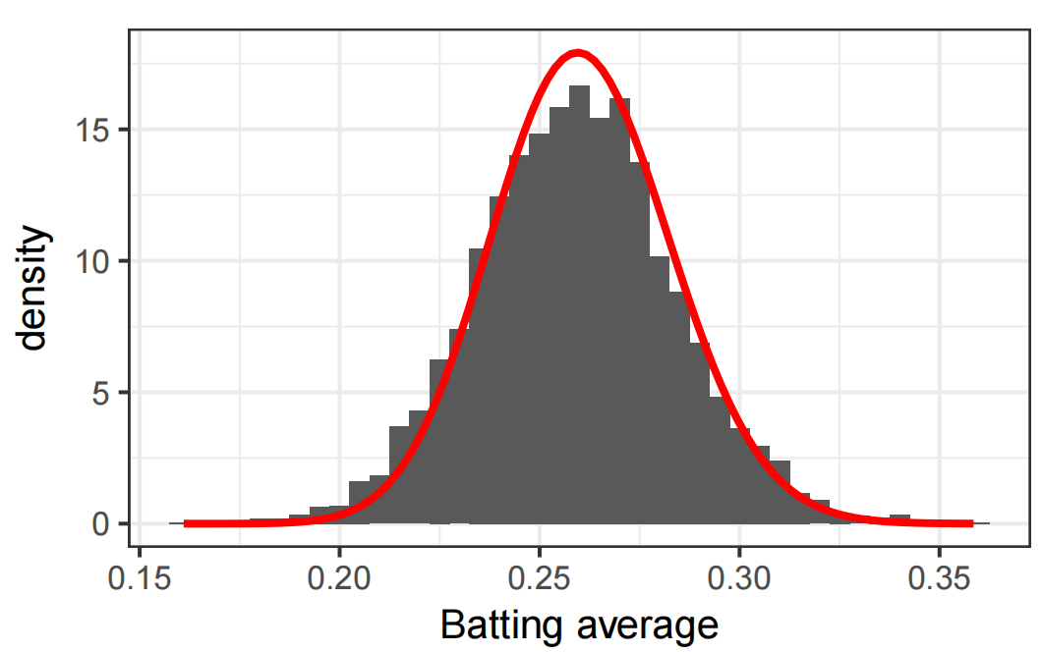

1. Use that distribution as a prior for each individual estimate by adding α0 to the number of hits, and α0 + β0 to the total number of at-bats.

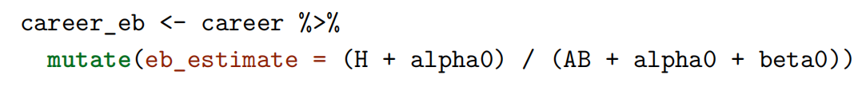

1. Based on Empirical Bayes Estimate we can select what are the best and worst batters?

## Computing a credible interval using the empirical Bayes Method

1. Estimate new parameters for each batter.

1. Calculate interval of 95% using qbeta function.



We can compare these results with the intervals produced by **binom.test**

**binom.test** uses Clopper-Person intervals and it’s more conservative (wider) than Jeffreys one.

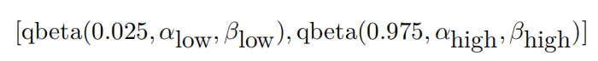

## False discovery rate control

This method solves problems associated with multiple testing.

Despite a batter has an expected value of 0.30 there is probability that the true batting average is bellow that number. If we check the distribution on of Hank Aaron with **pbeta** function with alpha1 and beta1, we will see that he has 17% of having a batting average bellow. This probability is known as **Posterior Error Probability**, or **PEP**

Notice that crossover point: to have a PEP less than 50%, you need to have a shrunken batting average greater than .300.

